Mission Statement :
"To give people the power to build community and bring the world closer together."

Product Suite:
- Facebook events
- Groups
- Live video
- Newsfeed
- Messenger
- Pages
- Instagram
- Whatsapp

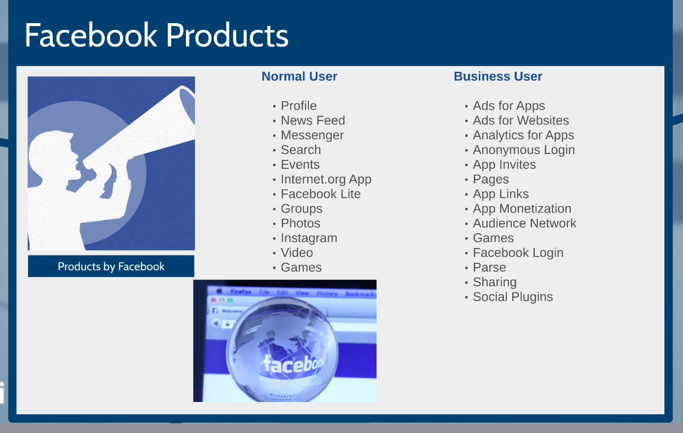

Newsfeed

- What is Newsfeed?
- Who is the most engaged user persona?
- Why is News feed so imp to that user?
- What are user goals?
- What are product goals?
- What Problems do we see?
- Which one is most imp to solve & why?
- Potential Solutions
- Cost Vs KPI trade offs
- Summary

Improve Newsfeed - IDEAS

- Prompt on friends birthday - EXISTS
- Add friendship journey- EXISTS
- Curated posts by season - EXISTS
- Post last year - EXISTS
- All or specific to people. ADD relevant Tabs - NEW
- AI/VR -??
- Community Engagement - ???
- Geo - fencing for feed??
- Local news for feed → Nextdoor meet News Feed - latest accq?
- Theme based post → business, sports, sentiment based posts(it’s like spotify mood playlists)***
- Better control over ad’s shown ??
- Filters:
  - People who I was close to
  - People who I haven’t liked or commented on their posts
- Having a professional profile so that people are more likely to accept requests from random people

Goals
Engagement
- Comment
- Sharing
- Liking
- Click Through rate
- Time spent per session
- View # number of feeds

Facebook Events - IDEAS

Private Events (Social)
For the Host
- Alert people when to leave so that they can reach on time
- Automatically create a chat group instead of allowing people to post on the group
- Order food based on preferences
- Find venue close to all the people
- Party Themes, Food, Decor, Entertainment ----??

For the Guests
- Gift for hostess/host
  - Payments
  - Marketplace
  - Near by
- Collaboration worksheet
  - Buy a gift for hostess
  - Plan for the party supplies/logistics etc

Public Events (Social, Biz, Community)
- Sending mini cards or something to each other

Messenger - IDEAS

- Communication tool
- Chat with people
- Audio/Video/Text

Facebook Messenger - IDEAS

- Add star to chat for later reference
- Clean up UI
  - Move out active groups
  - Remove shared days
  - Active now
- Get live responses from Public group
  - “How is X dish at bar Y?”
  - “I am cooking xyz what do I use for b”
  - Looking for opinion
  - Provides social validation

Some sort of social validation on FB pages, get badges within pages

Find a roommate:
- An additional feature on FB
- With exact same workflow as find as events

Playdates with kids near by

Pages

Goals

Business Goals
- Increase # of fans/like
- Increase reach, Page engagement
- Drive app installs, purchases etc

User Goals:
- Feel more informed, entertained, in the know
- Discovery of content/products
- How to ? --- products (marketplace)

What we like?

As a end user

- A platform to directly connect with public figures or business of you choice. Be in the know.
- Has a Web & Native app

As a business user
- Insights

Problems
- Authenticity
- Seamless integration of CRM features
  - Chat with customers
  - Chat bots
  - Scheduling
- Lack clean UI/workflow to set up pages
- Features are standalone & not end-to-end
- Content Not Interesting enough ---> I want to feel entertained
& Informed

Ideas

For a business user/creator
- Lead generation

For a consumer
- Interesting Content ---> relax, entertained
- Informed??
- Tag clothes from a brand
- Tag food items
- Offers/discounts
- Contents

